Assignment 3

Checkpoint 1.1

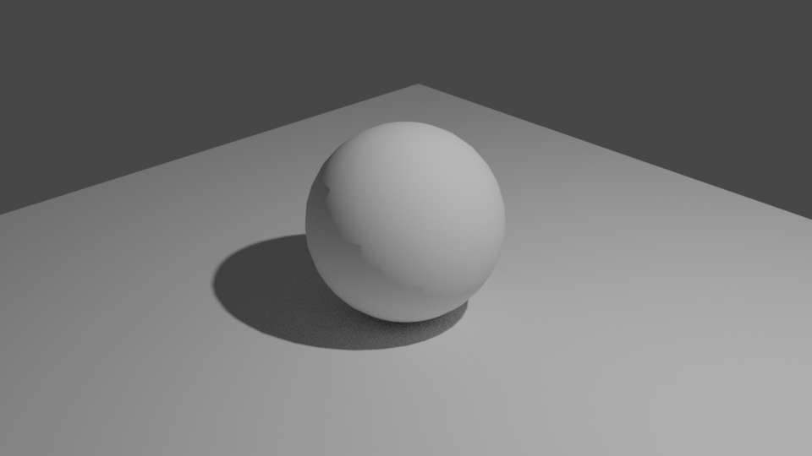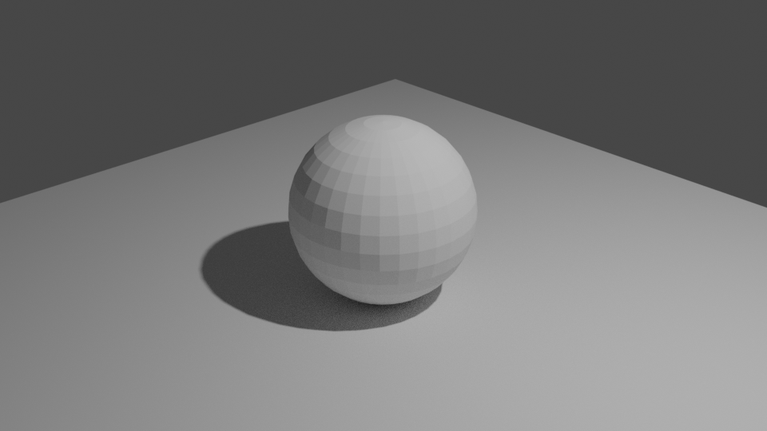

The smooth shading does not have visible edges like flat shading

Checkpoint 1.4: Render the image with subdivision+shade flat

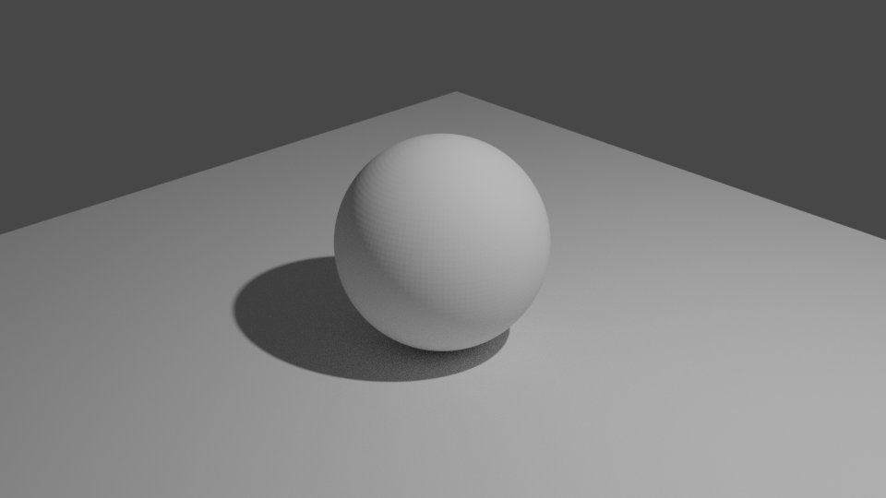

Checkpoint 1.5: render the image with subdivision + shade smooth

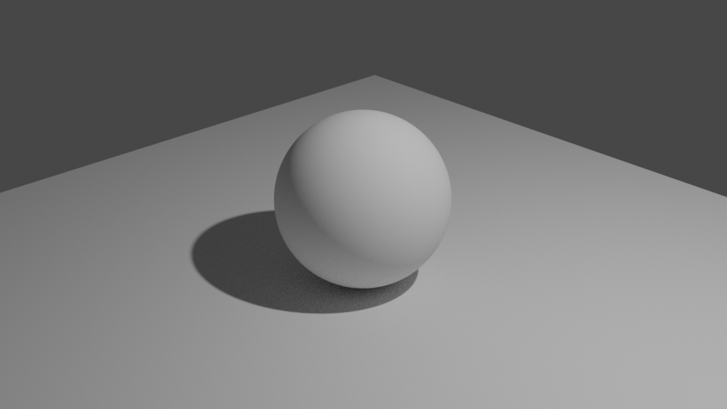

Checkpoint 1.6

With smooth shading, the entire object is smooth, while with subdivision, edges are still visible, but less noticeable. They can be used in combination in order to increase the efficiency of a scene. For example, using smooth shading when an object is close to the camera, but use subdivision when it is further away in order to use up less recourses

Checkpoint 2.1

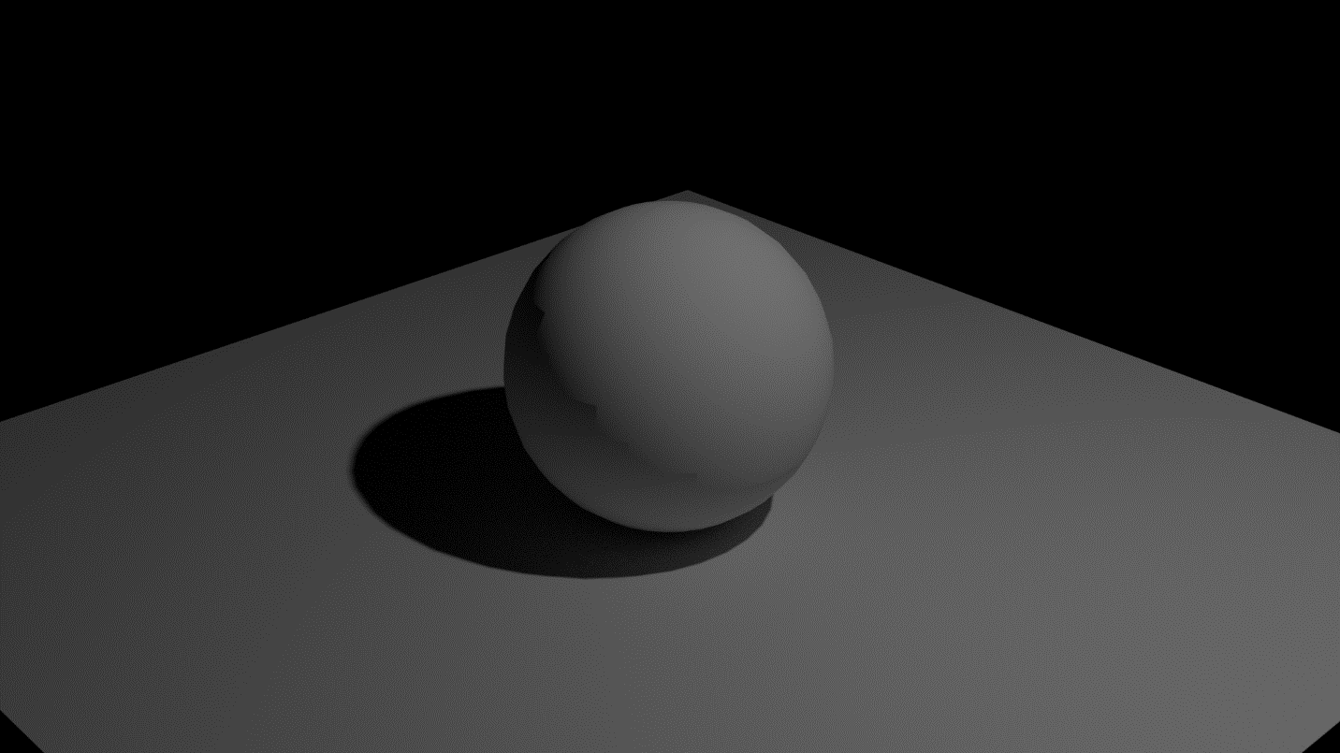

Checkpoint 2.2

The relationship between light power and irradiance are that, the higher the light level, the brighter the image is, and the lower light level makes the image darker

Checkpoint 2.3

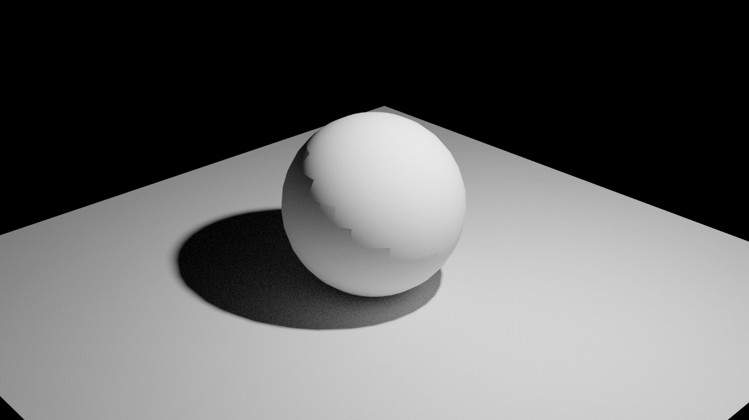

Checkpoint 2.4

When the light is closer, then the light appears to be brighter

Checkpoint 2.5

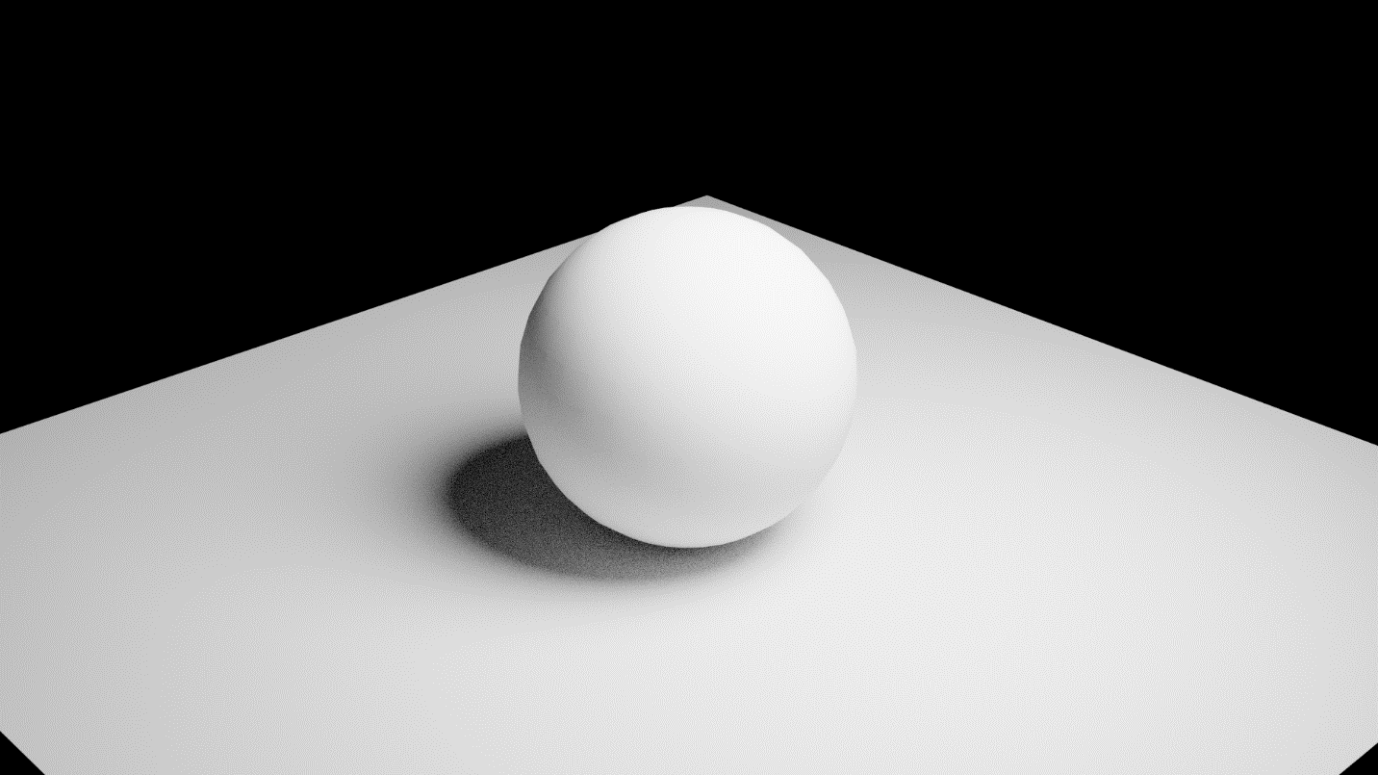

Checkpoint 2.6

The shadow is smaller with the area light

Checkpoint 3

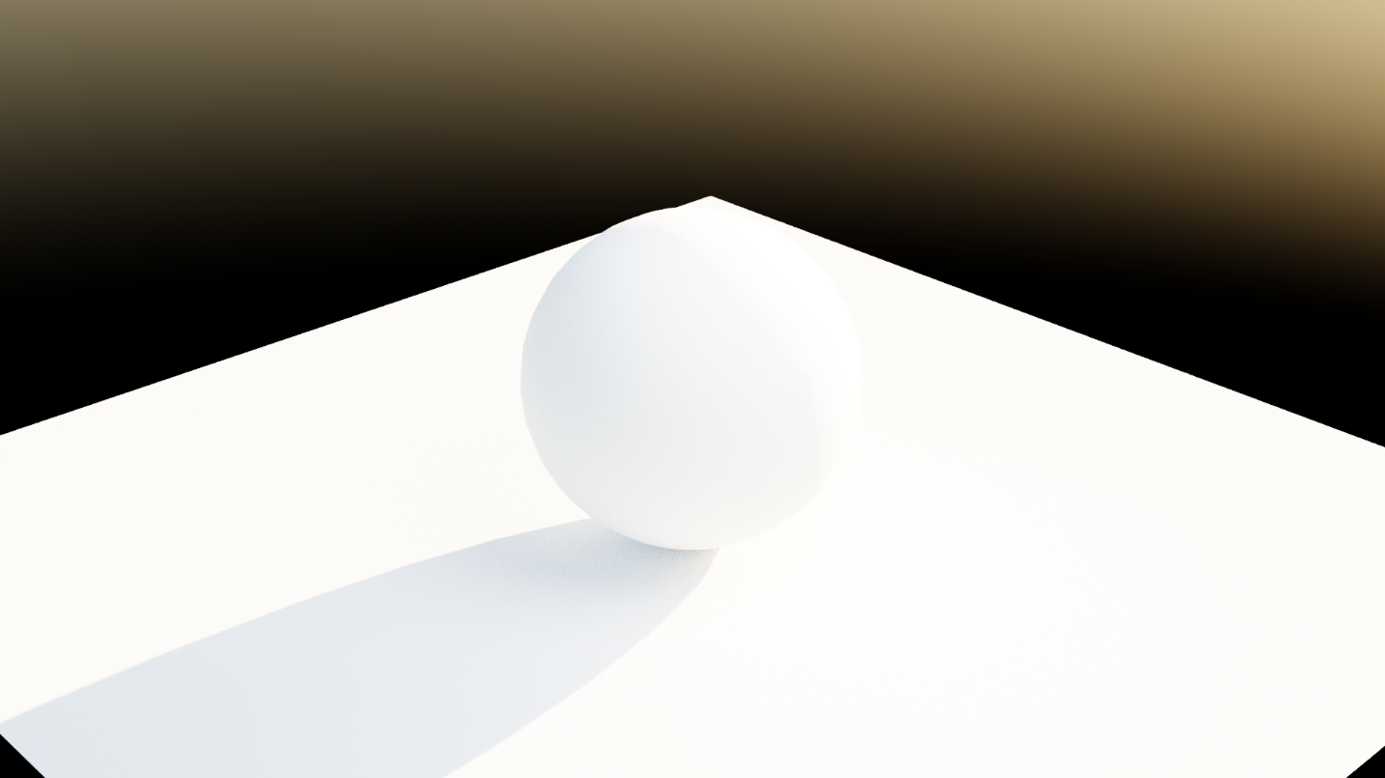

Checkpoint 4

